

**SRM Institute Of Science and Technology**

**Kattankulathur,Chengalpattu District**

18CSC305J - ARTIFICIAL INTELLIGENCE

PROJECT REPORT

STUDENT ADMISSION PREDICTOR USING MACHINE LEARNING

BY-

AMAN KALLA (RA1911003010640)

S ANISH KUMAR (RA1911003010641)

SRAJAN JAIN (RA1911003010662)

Under the guidance of –

Dr. M Aruna

OBJECTIVE

Student admission problem is very important in educational institutions. This paper addresses machine learning models to predict the chance of a student to be admitted to a master's program. This will assist students to know in advance if they have a chance to get accepted. The machine learning models are multiple linear regression, Decision Tree, and Random Forest. Experiments show that the Multilayer Perceptron model surpasses other models.

The main objective of this research paper is **to predict student admission**, using machine-learning algorithms, and find out the most effective whit respect to confusion matrix, accuracy and precision.

LITERATURE SURVEY

This section provides the literature review of the work that has previously done on predicting the chances of students enrolment in universities. There have been several project and studies performed on topics related to students admission into universities. (Bibodi et al. (n.d.)) used multiple machine learning models to create a system that would help the students to shortlist the universities suitable for them also a second model was created to help the colleges to decide on enrolment of the student. Nave Bayes algorithm was used to predict the likelihood of success of an application, and multiple classification algorithms like Decision Tree, Random Forest, Nave Bayes and SVM were compared and evaluated based on their accuracy to select the best candidates for the college. Limitation of this research as that it did only relied on the GRE, TOEFL and Undergraduate Score of the student and missed on taking into consideration other important factors like SOP and LOR documents quality, past work experience, technical papers of the students etc.

Bayesian Networks were used by (Thi et al. (2007)) to create a decision support system for evaluating the application submitted by international students in the university. This model was designed to predict the performance of the aspiring students by comparing them with the performance of students currently studying in the university and had similar profile during their application. In this way based on the current students profile the model predicted whether the aspiring student should be granted admission to the university. Since the comparisons were made only with the students who were already admitted in the university and the data of the students who were denied admission were not included in the research this model proved to be less efficient due to the problem of class imbalance.

GRADE system was developed by (Waters and Miikkulainen (2013)) to support the admission process for the graduate students in the University of Texas Austin Department of Computer Science. The main objective of the project was to develop a system that can help the admission committee of the university to take better and faster decisions. Logistic regression and SVM were used to create the model, both models performed equally well and the final system was developed using Logistic regression due to its simplicity. The time required by the admission committee to review the applications was reduced by 74% but human intervention was required to make the final decision on status if the application.(Nandeshwar et al. (2014)) created a similar model to predict the enrolment of the student in the university based on the factors like SAT score, GPA score, residency race etc. The Model was created using the Multiple Logistic regression algorithm, it was able to achieve accuracy rate of 80% only.

METHODOLOGY

The main objective of our experiment is to identify the effective and to predict the student admission prediction, therefore we applied machine learning classifiers Support Vector Machine (SVM), Random Forests, Linear Regression, Decision Tree

SYSTEM FLOW DIAGRAM

Student Admission Prediction

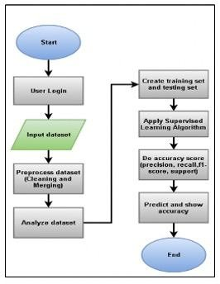

RESULTS AND DISCUSSIONS

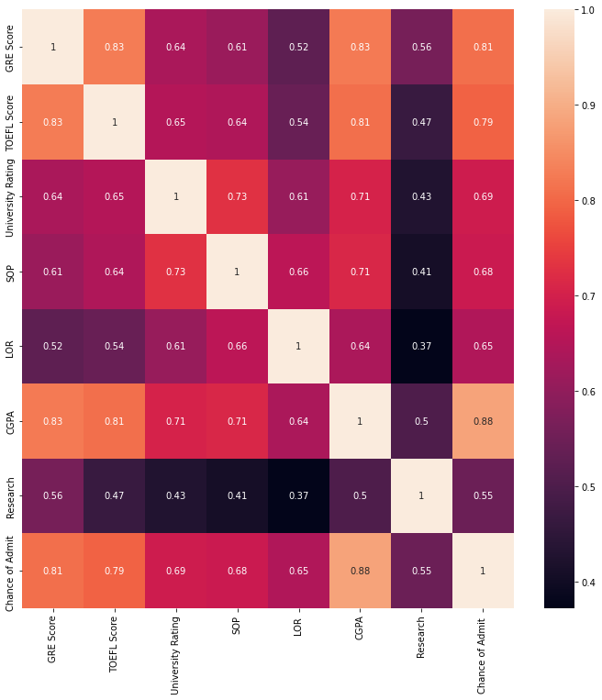

By projecting the different marking and evaluation metrics expected from the students trying to admit in a Masters degree in the x plane we are differentiating their matter of importance and their factorization in the selection process.

By projection the different derived statistics from each of the marking and evaluation metrics expected from the students trying to admit in a Masters degree in the y plane we are differentiating their effect to the total selection matrix.

The cross of all these factors with each derived statistics gives us a value from the range of 0 to 1. This value are completely experimental and will be different for everyone although the dependence shown will be uniform will be the same for all sample tests.

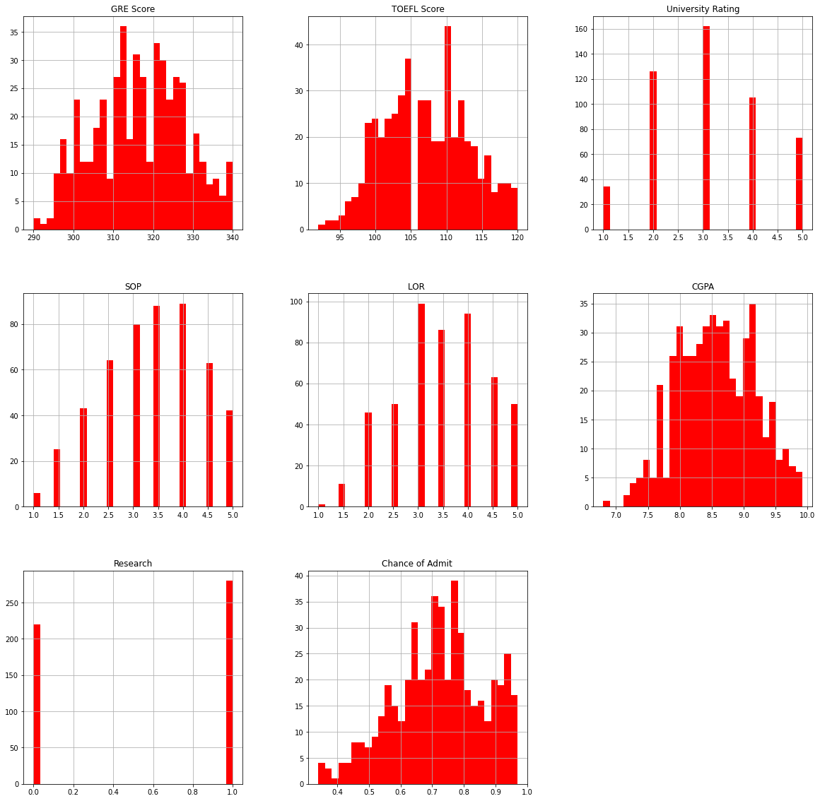

These are presentation of the above values in a tabular graph manner to see the changes they are occurring in each plane, here we can predict which all the training algorithms will be suitable to train the model giving the minimal loss progress during training.

The below graph shoes the training loss graph with the increasing epoch.

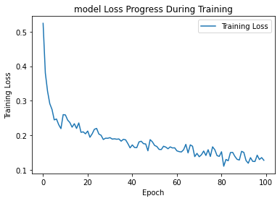

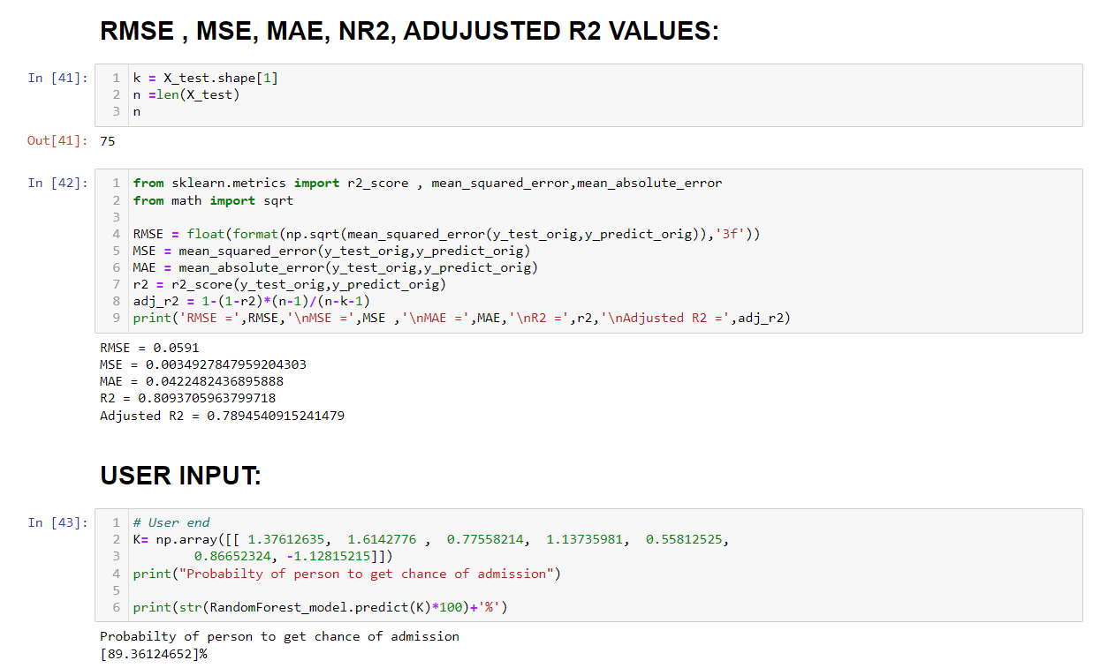

CONCLUSION

The main objective of this research was to develop a prototype of the system that can be used by the students aspiring to pursue their education in the USA.

Multiple machine learning algorithms were developed and used for this research.

linear Regression proved to best-fit for development of the system when compared with the Logistic regression model.

The model can be used by the students for evaluating their chances of getting shortlisted in a particular university with an average accuracy of 80%.

Decision Tree algorithm was used to predict the universities which were best suitable for a student based on their profile.

The random forest algorithm proved to be 75% accurate.

REFERENCES

1. Bibodi, J., Vadodaria, A., Rawat, A. and Patel, J. (n.d.). Admission Prediction System
2. Using Machine Learning.
3. Eberle, W., Simpson, E., Talbert, D., Roberts, L. and Pope, A. (n.d.). Using Machine
4. Learning and Predictive Modeling to Assess Admission Policies and Standards.
5. Jamison, J. (2017). Applying Machine Learning to Predict Davidson College ’ s Admissions Yield, pp. 765–766.
6. Mane, R. V. (2016). Predicting Student Admission decisions byAssociation Rule Mining
7. with Pattern Growth Approach, pp. 202–207.
8. MasterPortal (2017). MasterPortal.
9. URL: http://www.mastersportal.eu/countries/82/united-states.html
10. Mishra, S. and Sahoo, S. (2016). A Quality Based AutomatedAdmission System for
11. Educational Domain, pp. 221–223.
12. Mozenda (n.d.). Mozenda.
13. URL: https://www.mozenda.com/
14. Nandeshwar, A., Chaudhari, S., Sampath, V., Flagel, A., Figueroa, C., Sugrue, P.,
15. Ahlburg, D. and Mcpherson, M. (2014). Predicting Higher Education Enrollment in
16. the United States : An Evaluation of Different Modeling Approaches, International
17. Journal of Operational Research 19(26): 60–67.
18. URL: http://ezproxy.bethel.edu/login?url=http://inderscience.metapress.com/content/fr20314q1862content/uploads/2008/11/DMWVU Project.pdf